(Approx. 1,620 words)

Got Windows 8?
by Barney Babin, member and instructor for XP, Vista, Worships & Win 7, Cajun Clickers Computer Club, LA
December 2012 issue, Cajun Clickers Computer News
www.clickers.org
ccnewsletter (at) cox.net

AUTHOR'S NOTE: This article will be in two sections. The first section assumes that you have purchased a new non-touch screen computer that has Windows 8 (W8) installed. The second section will deal with upgrading to W8. All of the W8 comments in either section apply to W8 functionality.

Many people have a new operating system on their new computers – Windows 8. I have been running W8 Pro, the W8 flavor that meets my requirements, since the release date of October 26 and have a few tips that will assist you in becoming familiar with the new operating system. One thing to remember is that the mouse right click is going to be a very useful tool. If your new system includes a touch screen, all of those functions perform flawlessly in W8, which is the first Microsoft operating system specifically designed for touch screen and tablets, but also works on desktops, notebooks, laptops, etc.

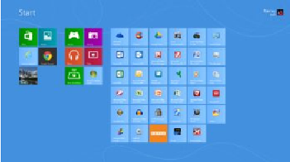

First, the Start menu is gone, but has been replaced with the Start Screen, which is the weird looking screen that you first see when W8 boots. This screen can be tailored to your requirements and tastes and if you have a Smartphone, this screen will look very similar to the widgets there. You can add and remove the tiles (former icons), change their size and position, etc. by using the mouse right click and looking at your options on the bottom left of your screen. While you are on the Start screen, just start typing the word help (you don't click anything before you start typing, which is how the Start screen search function works). Click Help and Support and you will be taken to a screen that has everything you wanted to know but was afraid to ask. Just click one of the groups and you will be taken to another screen that will allow you to “get your feet wet” with tutorials or comments about things in W8. I strongly recommend that you do this.

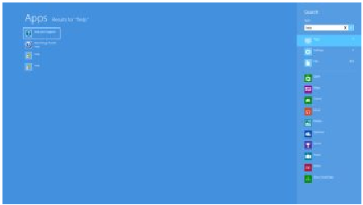

Perhaps the second most important change associated with W8 is the charms bar, which can be accessed by moving your mouse to either the right top or right bottom corner of any screen that you are currently on – or use the keyboard shortcut Windows Logo key and the letter C simultaneously (WL + C). The Charms bar will slide in and offer five options.

The Settings option is where you can tailor the system to your requirements (Don't overlook the Change PC Settings option at the very bottom of the settings screen. This is where you can change a lot of things, including the lock screen, start screen, and
account picture). I strongly urge you to click every one of these charms bar options to see what’s available. Many of these options will look very familiar to you if your old operating system was either Vista or Win 7. If you want to see all the apps (previously called programs) installed on your computer, while on the Start screen, either right click and then click the All Apps icon at the bottom right of the screen or depress WL + Q. You can scroll through these apps easily by rotating your mouse wheel. If there are apps that you frequently use and wish to have them on your Start Screen, right click the app tile, look down on the taskbar area at the bottom left of the screen, and select “Pin to Start”, or if you would like to have the icon on the desktop taskbar, then select “Pin to Taskbar”.

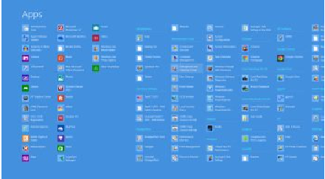

You will discover that one of the tiles on your Start screen says Desktop. When you click that icon, you will be taken to your familiar looking desktop, with the start button missing, but with all other looks, feels, and functionality of the desktop that you are familiar with, so no further comments will be made on the desktop. Once you leave the start screen and wish to return, just depress the WL key and perform your desired
function. To go back to the last app that you were using, depress the WL key again.
Another tile on the Start screen is labeled Store.

Once you leave the start screen and wish to return, just depress the WL key and perform your desired function. To go back to the last app that you were using, depress the WL key again.

Another tile on the Start screen is labeled Store. Click this tile and you will be taken to the Microsoft App Store, which has the same functionality as the Smartphone app stores. Scroll through the item groups with your mouse wheel or, once again depress WL + Q to search the app store for your particular program or group. Once you type in this information into the search window, the associated apps will appear on the screen.
Remember, this is a startup app store, so the number of apps currently available is not as large as the iPhone or Android app stores, but the current app number is larger than either of these mentioned stores was at their startup.

Now, let's assume that you have Windows XP, Vista, or Windows 7 and you want to upgrade to W8. CAUTION: W8 is sold in two versions: Windows 8, Pro, Enterprise, etc. and Windows RT. The RT version is for Tablets with ARM processors and will not allow
Windows programs such as Office, etc. to function and should not be available for purchase. Microsoft has an unbeatable deal running right now that allows you to purchase W8 Pro for $39.99, the lowest price Microsoft has ever offered the public for an operating system. To begin the upgrade process, go to http://windows.microsoft. com/en-US/windows8/upgrade-to-windows-8 to download the upgrade assistant into your current operating system. The upgrade assistant will analyze both your computer
hardware and the installed programs to determine if they are compatible with W8. Once this process has finished you will then start the upgrade process, which includes purchasing your selected flavor of W8 (at the time I purchased, Microsoft also included Windows Media Center for free). After purchase, the assistant wizard continues the upgrade process by asking if you want to upgrade by formatting the hard drive, which
requires you to reinstall everything after the upgrade, or if you wish to upgrade and transfer all of your existing W8 compatible programs and your data, usually found
in the My Documents folder. (As a test, I performed the upgrade both ways to see if the file and folder transfer would bloat the system or not. It did not, but there is a Windows.old folder that contains your old operating system goodies and your documents as backup, which bloats the system until it is uninstalled, in my case
almost 20GB in size.) I would strongly recommend that you choose the option of transferring your programs and files. This makes the process extremely painless and saves you the time and effort of reinstalling all of your programs again.

I have installed W8 upgrade with program and data transfer on about 10-15 computers and have had only one glitch in the process, which was a program that was incompatible and was prompted to totally uninstall it before the process could continue, which I did and the process continued uneventfully.
So how about more “weird” things associated with W8? The first thing that will not be immediately noticeable is the fact that the F8 safe mode function is no longer applicable during boot-up. W8's safe boot security process does not allow this function, plus other
things such as stack overflow prevention, etc. So….How do you now access safe mode?? There are two ways: the easy way and the convoluted, but user friendly and a onetime only process. The easy way is to go to search and type msconfig. When that window comes up, click the boot tab, click Safe Boot and minimal if no network is required, or click Safe boot and Network if networking is required in safe mode, then click OK and reboot your computer.

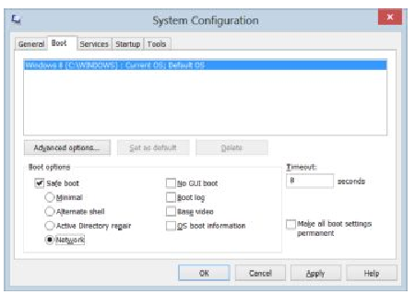

When the boot process is complete, your system will be in Safe Mode. Perform the functions that you need to do and then go to search, type msconfig, remove the Safe
boot option on the Boot tab, click OK, and restart your computer, which will then boot normally. If you do not change the msconfig option prior to reboot, your system will restart in safe mode every time a restart is performed until you do so!

The convoluted safe mode option is: in search, type: safe mode; click the settings bar and then advanced startup options; scroll down to advanced startup and click the restart now button; the computer will start a restart process and bring up another screen; click troubleshoot; on the troubleshoot screen click Advanced Options; on the Advanced Options screen click Startup Settings; on Windows Startup Settings click the restart button; on the Startup Settings menu, type either 4, Enable Safe Mode or 5, enable Safe Mode with Networking; your computer will now enter safe mode. When you are finished, just restart your computer and it will boot normally.

Another change in W8 is that your Windows Explorer now has a ribbon, which can be minimized by right clicking. Task Manager also looks vastly different and is more user friendly. Did I cover all of the bells and whistles? No, but I did cover enough for you to better understand this new Microsoft operating system, so go forth and conquer.

